Exp3:-
Title of the program:-
Write a program to compute the GCD & LCM of two numbers. Write the Algorithm of the program.
Algorithm:-
Step 1:- Take input a, b, gcd, product, lcm
Step 2:- Take user input in a, b
Step 3:- set product = a * b
Step 4:- set gcd = a % b go to step – 5
Step 5:- set a =b go to step – 6
Step 6:- set b = gcd go to step – 7
Step 7:- if (a % b !=0) go to step – 4
else go to step – 8
Step 8:- set lcm = product / gcd
Step 9:- print gcd
print lcm
Program instruction:-
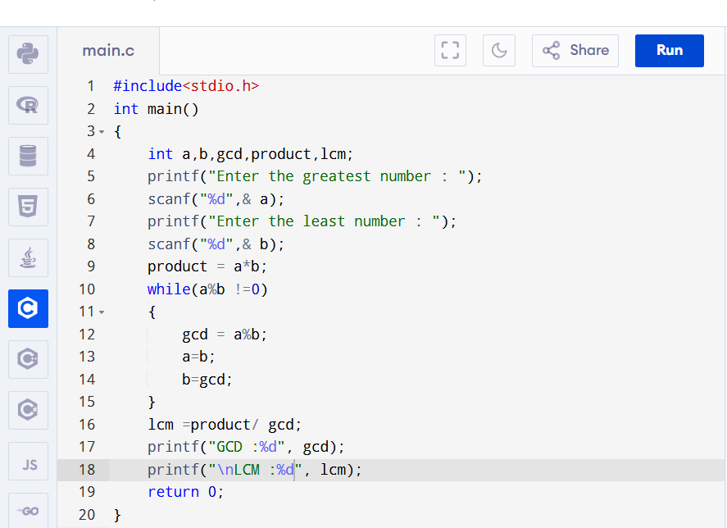

Output:-
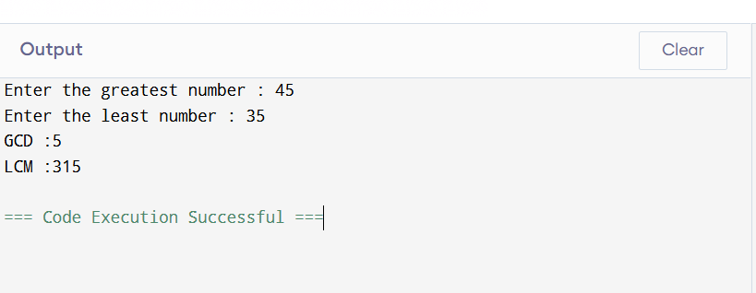

Exp4:-
Title of the program:-
Write a program to check a 4 digit number to be divisible by 9 or not without using modulus operator. Write the flowchart of the program.
Flowchart:-
Start

int n,sum=0,reminder
Take the value of n
reminder=n-(n/10)*10)
n=n/10
if
n!=0
print The number is divisible by 9
print The number is not divisible by 9
End
Yes
No
No
Yes
sum=sum+reminder
if
sum-((sum/9)*9)==0

Program instruction:-
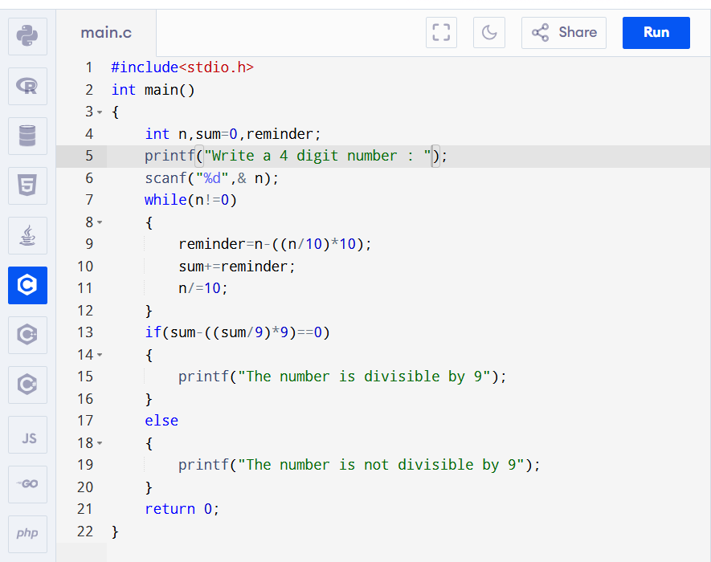
Output:-
